**Giza Governorate Mid- Year Exam**

**Hadyek October Directorate Grade 3**

**English Inspectorate Time : 2 Hours**

1. 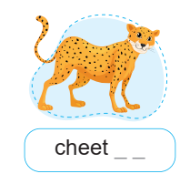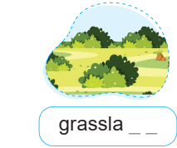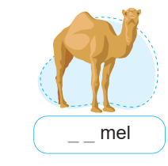**Listen and write the missing sound:**
2. 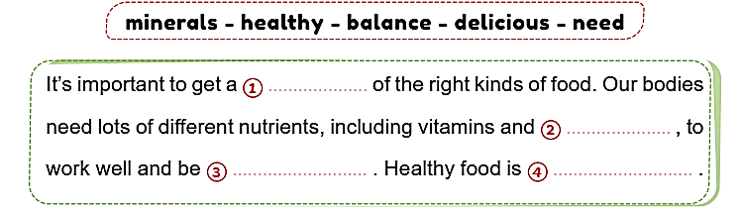**Read and complete the text with the words in the box:**
3. **Read the following passage then answer the questions:**

Today, Ahmed is at the track. There is a big sports event. Lots of athletes from different schools are competing. They are wearing red, blue, green and black. There are competitions in running, jumping, and throwing.

1. **Answer the following**
2. Where is Ahmed?

…………………………………………………………………………………………………………………………………………………

1. What colors are the athletes wearing?

…………………………………………………………………………………………………………………………………………………

**4-Choose the correct answer:**

1. There is a big…………………………event. (war-sports-art)
2. There are competions in…………………………… (football-tennis-running)
3. Lots of athelets from different …………………………are competing.

(school- libraries- cities)

1. They are wearing red, blye green and…………………..(white-gray-black)

**5-Choose the correct answer:**

1- What…………………..he going to do? ( am – is – are )

2-Will she …………..lunch? ( cook- cooking – cooks)

1. You shouldn’t …………….cookies every day. (eats-eat-eating)
2. Will he win today? No, he………………………(will-won’t-would)

**6-Read, order and write:**

1. house- might – **Omar** -in – the -be.

………………………………………………………………………………………………………………………………

1. moves – slowly – **A sloth**- very.

………………………………………………………………………………………………………………………………

**7-Write a paragraph of about (20) words (3 or 4) sentences using the guiding elements**

**Your favorite animals**

* Lions
* Zoo
* Giraffes

…………………………………………………………………………………………………………………………………………………………………………………………………………………………………………………………………………………………………………………………………………………………………………………………………………………………………………………………………………………………………………………………………………………………………………………...…………………………………………………………………………………………………………………………………………………………………………………………………………………………………………………………………………………………………………………………………………………………………………………………………………………………………………………………………………………………………………………………………………………………..…………………………………………….

………………………………………………………………………………………………………………………………………………………………………………………………………………………………………………………………………………………………………………………………………………………………………………………………………………………………………………………………………………………………………………………………………………………………………………………………………………………………………………………………………………………………………………………………………………………………………………………………………………………………………………………………………………………………………………………………